Parks Accessibility Conference 2023

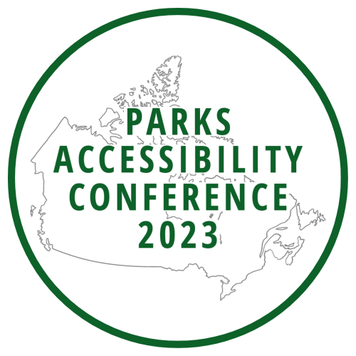

Join us virtually for our second year

Tuesday July 25th to Thursday July 27th, 2023

Register for free today!

www.pac2023.ca

Making Canada’s National Parks more

accessible to people with disabilities

